Volunteer Role Title | Role Number
Events and Engagement Volunteer – Marine
Reserve, Project, Team or Area
Visitor Engagement Team / Yorkshire Coast (Scarborough, Filey, Flamborough and Bridlington)

Volunteer Manager
Sophie Atkinson, Inspiring People Officer - Marine
Why do we need this volunteer?
Nature is amazing and we want to tell everyone! Yorkshire Wildlife Trust is creating a county rich in wildlife and we need passionate, inspiring volunteers to help people to develop a connection with nature. Across our sites the Trust runs regular events, from education sessions with local schools, to Seashore Safaris and Marine Life Past and Present events for the public. We are looking for people who can inspire others and help us to deliver these events throughout the seasons.

What will the volunteer be doing?
Staff and volunteers run a range of bookable events and school/group visits along the Yorkshire coast throughout the year to inspire people about the marine environment. In this role, you will help to deliver these indoor and outdoor activities and share your passion for the marine environment with others, providing a high-quality visitor experience.
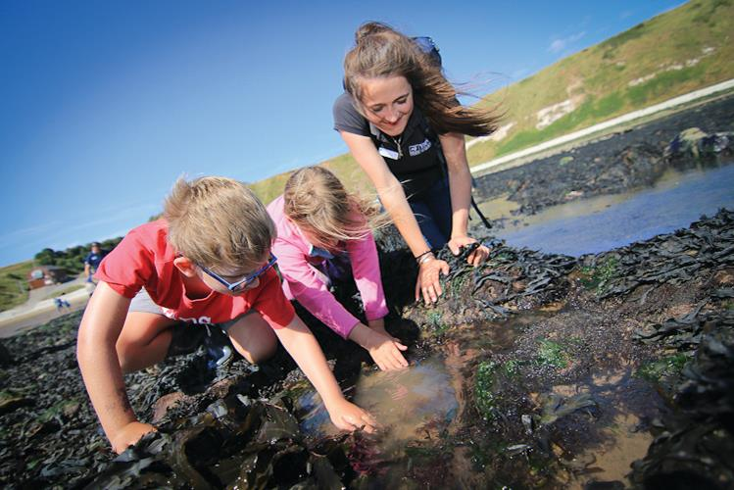

Have fun inspiring young people and exploring rockpools!
(Photo Credit) YWT

Tasks will include:

- Assisting the Inspiring People Officer (Marine) in the smooth running of public events and school/group sessions, both indoors and outdoors
- Assist in the preparing of equipment, resources and materials
- Assist in the room set up
- Back mark groups so no-one gets lost
- Check in people on events attendance list
- Meet and greet participants
- Engage with visitors and communicate onward messages to signpost to other events and activities
- Assist in the packing away of materials and equipment correctly
- Feedback event attendance to Inspiring People Officer - Marine
- Take a lead on running activities within events/sessions such as fossil hunting and rock pooling, for example if a school group is over 30 people and needs to be split up. This is something which can happen once you feel confident – full induction and training will be provided.
- Working as part of a team to engage with members of the public at the Living Seas Centre
- Potential key holding responsibilities.

Experience, knowledge and skills needed for this role
Essential:
- Ability to share knowledge clearly and inspire others
- An infectious passion for nature and being outdoors
- Willingness to have fun outdoors in all weathers
- Capable of working on your own and with others
- Ability to be reliable and punctual
- Ability to follow instructions and on occasions work with minimum supervision
- Reasonably physically fit
- Good communication skills
- Confident in communicating and presenting to others
- Good time keeping
- Awareness of yours and others safety

Desirable:
- Experience of working with children and those with Special Educational Needs – don’t worry if you don’t have this experience though!
- Passion for and knowledge of the marine environment and British wildlife
- Awareness of safety outdoors
- Experience of presenting to a wide audience
- First Aid certificate
- Safeguarding training

Does the volunteer need a driver’s license? No but please be aware that travel to the Living Seas Centre at Flamborough Head on public transport can be difficult.

What’s in it for the volunteer?
- Opportunity to share your knowledge and skills
- A chance to inspire others about the natural world
- Development and use of teamworking and leadership skills
- Development and use of communication skills
- Development and use of engagement skills
- Travel expenses, uniform and necessary training will be provided
- Access to a free volunteer training programme
- 15% discount in Yorkshire Wildlife Trust shop and 15% discount at cafes when volunteering
- Be part of a fun and inspiring team
- A chance to learn more about the amazing Yorkshire coast and the wildlife that calls it home
Where is the role based?
Yorkshire Coast (Scarborough, Filey, Flamborough and Bridlington) This role will be based in discussion with the volunteer on what is most convenient for them and their home location.

Commitment
As much as you want but preferably at least one day each month. We are recruiting volunteers in the different areas that our events take place so people can volunteer for the events that are local to them. Volunteers will be emailed a calendar of upcoming events and they can choose which dates to volunteer. Events and school/group sessions can take place on weekdays and weekends.

We are particularly looking for volunteer support to help us host our annual Yorkshire Puffin Festival in North Landing, Flamborough over the weekend of Saturday 13th and Sunday 14th May 2023.
Duration
Ongoing – Most of our events happen between April and September. This is when you will be busiest.
Does this role involve working with children or vulnerable adults?
Yes
Will the role involve any other sensitive tasks for which we may wish to check suitability via references or a criminal records check?
An enhanced disclosure is not needed for this volunteer role but it will be subject to reference checks as it involves volunteering with families and school groups.

If you are interested in applying for this role, please complete a volunteer application form and send it into volunteering@ywt.org.uk

On Thursday 23rd February and Saturday 11th March we will be running taster sessions from 11am – 1pm at the Living Seas Centre at Flamborough. If you’d like to discuss more or to book a place then please email volunteering@ywt.org.uk

